**7.USING SET OPERATORS**

**B.ELUMALAI**

**230701084**

**Find the Solution for the following:**

**1. The HR department needs a list of department IDs for departments that do not contain**

**the job ID ST_CLERK. Use set operators to create this report.**

select Department_id from employ

minus

select department_id from employ where job_title='stock clerk';

**OUTPUT**

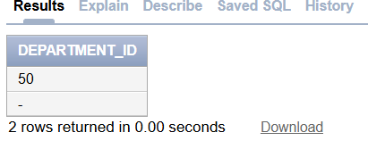

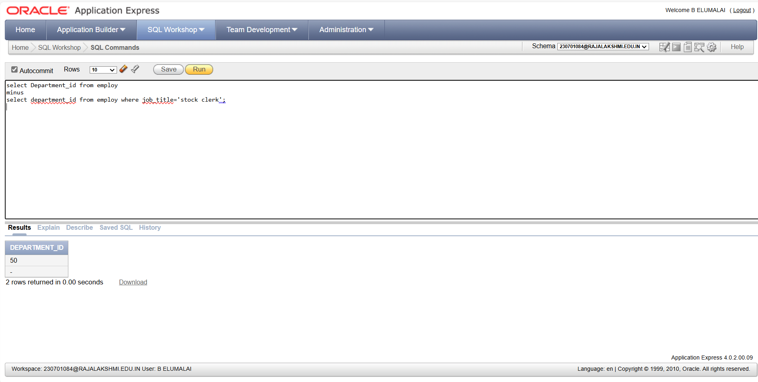

**2. The HR department needs a list of countries that have no departments located in them.**

**Display the country ID and the name of the countries. Use set operators to create this report.**

select country,country_id from employ

minus

select country,country_id from employ where Department_id is NULL;

**OUTPUT**

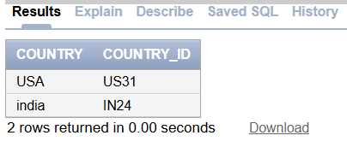

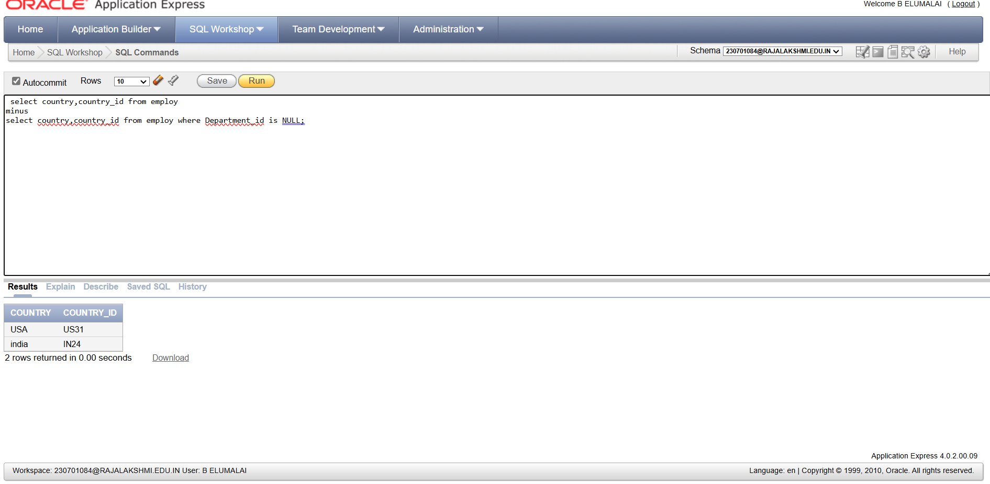

**3. Produce a list of jobs for departments 10, 50, and 20, in that order. Display job ID and**

**department ID using set operators.**

SELECT Job_id, Department_id

FROM employ

WHERE Department_id = 10

UNION

SELECT Job_id, Department_id

FROM employ

WHERE Department_id = 50

UNION

SELECT Job_id, Department_id

FROM employ

WHERE Department_id = 20;

**OUTPUT**

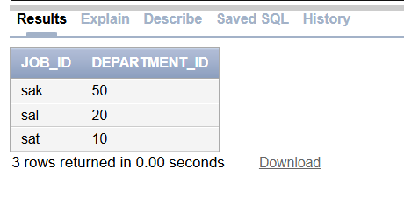

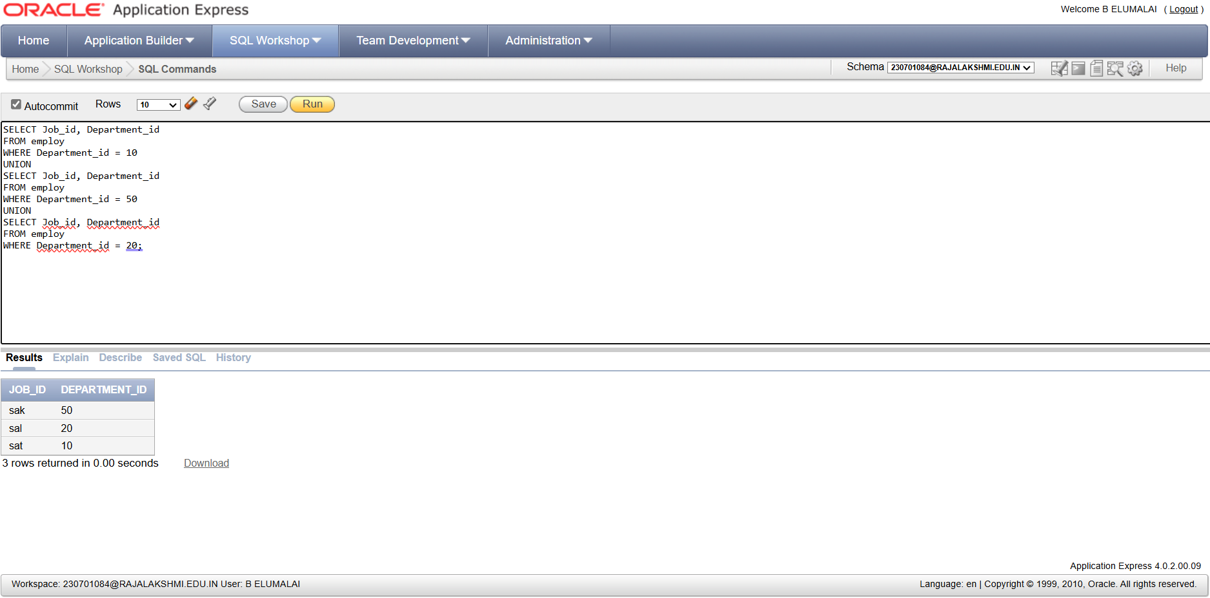

**4. Create a report that lists the employee IDs and job IDs of those employees who**

**currently have a job title that is the same as their job title when they were initially**

**hired by the company (that is, they changed jobs but have now gone back to doing**

**their original job).**

Select Employee_Id,Job_Id from employ

intersect

Select Employee_Id,Job_Id from job;

**OUTPUT**

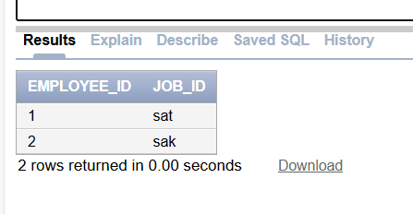

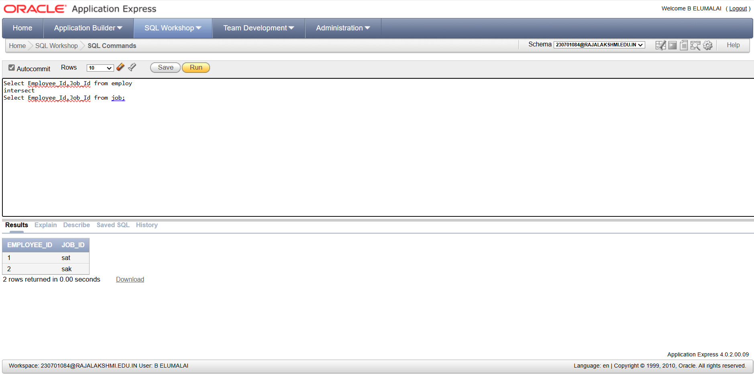

**5. The HR department needs a report with the following specifications:**

**- Last name and department ID of all the employees from the EMPLOYEES table, regardless of**

**whether or not they belong to a department.**

**- Department ID and department name of all the departments from the DEPARTMENTS table,**

**regardless of whether or not they have employees working in them Write a compound query to**

**accomplish this.**

SELECT

Last_name,

Department_id,

TO_CHAR(NULL)

FROM employ

UNION ALL

SELECT

TO_CHAR(NULL),

id,

name

FROM Department;

**OUTPUT**

